Project title: Hand Sanitizer sensor

Your name & email addresses:

Name: Jamie Bredin Email: S00211357@mail.itsligo.ie

Name: Sean Henry Email: S00212719@mail.itsligo.ie

Name: Ariane dos Santos Email: S00213750@mail.itsligo.ie

Name: Rian Bolger Email: S00213015@mail.itsligo.ie

Links to:

Trello Page: <https://trello.com/b/WINwZc5Z/internet-of-things>

GitHub Team Page: https://github.com/Adsant0s/IoT-Project-2021

Links to sites we used for Research:

https://synapse.koreamed.org/articles/1144872?viewtype=pubreader

https://www.atlantis-press.com/proceedings/ijcse-20/125946360

https://iopscience.iop.org/article/10.1088/1757-899X/1007/1/012164/meta

Outline of the problem to be solved – supported by your research

The Problem

The problem we were trying to solve was related to the global pandemic Covid-19, We all know how sanitizing our hand has become so very important to lower the chances of getting Covid-19 and keep as hygienic as possible during this crisis,

Shop’s rule of sanitising hands

We see a lot of shops around my area having to implementing a rule where you must sanitize your hands before you enter the shop and when you leave to stop the spread of Covid-19

So that when you are in the shop you would spread the virus around the shop because you can pass it on but you may not have the symptoms this way we can help lower the chances of catching it and it is the same for everyone else who enters the shop because the shop is a very public facility and those types of places have become the most dangerous because of Covid-19 as you have a higher chance since you are around so many people from different places so it’s so important for you to secure your own home from this virus and keep it hygienic and virus free,

Sanitizing hands at home

But we noticed that all people in our group either did not sanitise their hands enough or forgot too and we seen this as a problem, so we started to come together to fix this problem as it is more important in times like this than ever

but when you go back home you should sanitize your hands before you enter your home and before you leave your home in case you bring back any symptoms and spread it around your home to lower the chances of getting Covid-19 and bring it back to your home

Summary of the Project solution

The Summary of the project which was trying to stop people who enter there homes or whatever building this was placed to alert them or of a person who enters the door to sanitise their hands because we all have to do our part to keep covid-19 and keep our hands sanitised and to stop the spread of Covid-19

Idea

So, we came up with an idea that uses the Arduino Yun and the groove kit and we designed it for people’s home’s front and back door’s that will detects when people come in or out of the house,

Using a motion sensor to trigger when someone enters or leaves through the door and then telling them to sanitise their hands with a buzz that comes from a buzzer that is positioned near the door frame or next to the door which is all triggered by the motion sensor,

Motion sensor

We then put the motion sensor close to the door as possible mounted on the wall, so we could get the best detection of the door opening and closing as people would be coming in or out of the door and to also have it so it would not get triggered by any other unwanted motion or disturbances that could cause it to trigger,

The motion Sensor was much better than the sound sensor which might have gotten triggered by any unwanted noise which might potentially set it off and start the buzzer,

The motion Sensor was also a lot better than the light sensor because the light sensor needed light or a light source for every time someone would enter or try to leave through the door which was very hard to do and was a lot easier to do with the motion sensor

Button

Then we would put the button in a very accessible spot so that it is easy to press and to get too so you would not waste a lot of time pressing it but also having close to the Arduino Yun so that all the cables can reach all the components of the sensor,

Working of the protype

When the door opens or closes from a person entering it will be set off by the motion of that person walking through the door or leaving through the door which will then trigger the Arduino Yun and it would tell the buzzer to buzz signalling you to sanitize your hands,

After sanitation

Then after you have sanitised your hands you will press the button to signify the Arduino Yun to tell it that you sanitised your hands so that it will tell the buzzer to stop buzzing until the next time someone enters or leaves the house and start the cycle again,

After Sanitising your hands

This way you will always have your hands sanitized before you leave your home and when you come back to your home as well keeping your home hygienic and clean and keeping free from Covid-19 and doing your part to keep this pandemic away and stopping the spread of Covid-19,

List of project requirements

The first Project requirement is an Arduino Yun and a groove kit, As it is very important as it has all the hardware and is also needed because of the code we used,

As the Arduino Yun and groove kit come with a all the equipment you will need for to make this project work, Another reason is because the code we used to code our Arduino Hand Sanitiser has to be used an Arduino Yun as that is what it was initially designed for and also what we used to run out tests to get the most effective prototype and also to get the code to work the way it was designed for,

As the code may not work as perfectly on a different set up or a different type of Arduino device

The second Requirement is that you will need a motion sensor or some kind sensor that will be able to pick up someone coming the door,

we found out that the motion sensor is the best way sensor we found through are research that works the best because it picks up only motion,

The light sensor is not as good as it need a light source every time someone enters through the door or leaves through the door it and also can be bad because it could be also triggered by any unwanted light that could be from the sun or from other light sources

The sound sensor is not any better for are prototype than the light sensor as it would get triggered by the noises off the door when it is opened or closed the only issue with this is that it is more prone to be set off by unwanted noises if it was beside the door which would be no good for our prototype

The Third Requirement is the need of a button to stop the buzzer from buzzing and being able to put it in a very accessible position so its easy for users to stop the Arduino Yun from buzzing after they have sanitized their hands and so that they don’t trigger it again by sticking by for a long time trying to figure out where the button is which will only trigger the cycle again if they pressed it

The Fourth Requirement To have the sensor positioned correctly,

Basically to have the motion sensor in a place where someone entering the door or leaving through the door will trigger the motion sensor to tell them to sanitise their hands and not have it getting triggered by other motions or letting it get picking up other disturbances as this could also trigger the motion sensor as it is very sensitive and will pick up any type of motion if left out in the open and not positioned correctly which will become a huge inconvenience because the Arduino Yun will start to buzz and wont stop till the button is pressed which if it is not pressed this is very bad for the Arduino Yun as it was not designed to go for long periods of time buzzing of being in use which could damage the buzzer as it is buzzing all the time or also damage the Arduino Yun and groove kit as it was not designed for such long and continued use

The Fifth Requirement is to get a way to mount it onto a door frame or wall that is near the door,

You will need to mount the motion sensor on the wall or the best place in your location that gets the best detection of people walking in through the door and leaving through it and so it doesn’t get picking up other motions or disturbances that is not people coming in and out the door, After the motion sensor is mounted the Arduino Yun will have to be close by as the cables cannot stretch that far but it will also have to be on the inside of inside some kind of waterproof case which it can still get power if it be from a power bank or a different type of power supply to make sure the Arduino Yun can get power while also not letting water or any type of moisture in which could cause faults and issues for the Arduino Yun and the buzzer as it was not designed to be protected from these issues, Then the button will also have to be put in a safe place protected from the outside weather conditions and also while being able to be found and pressed with ease

The Last Requirement is to have hand sanitiser,

You will need hand sanitiser for the last requirement, Which can either be a bottle of hand sanitiser or a refillable bottle which can be refilled when it is low, This is important as if there is no hand sanitiser near by the people that walk in through the door and out through it will start to get a little annoyed over this pointless noise and also if there was no hand sanitiser there would be no point of this prototype as this is all about stopping the spread of Covid-19 by helping people sanitise their hands to keep their hands which are usually touching everything and will come in contact with a lot of things and thanks to this protype we are able to keep people’s hands as hygienic as possible to stop the spread of Covid-19 and to help everyone to their part this these trying times

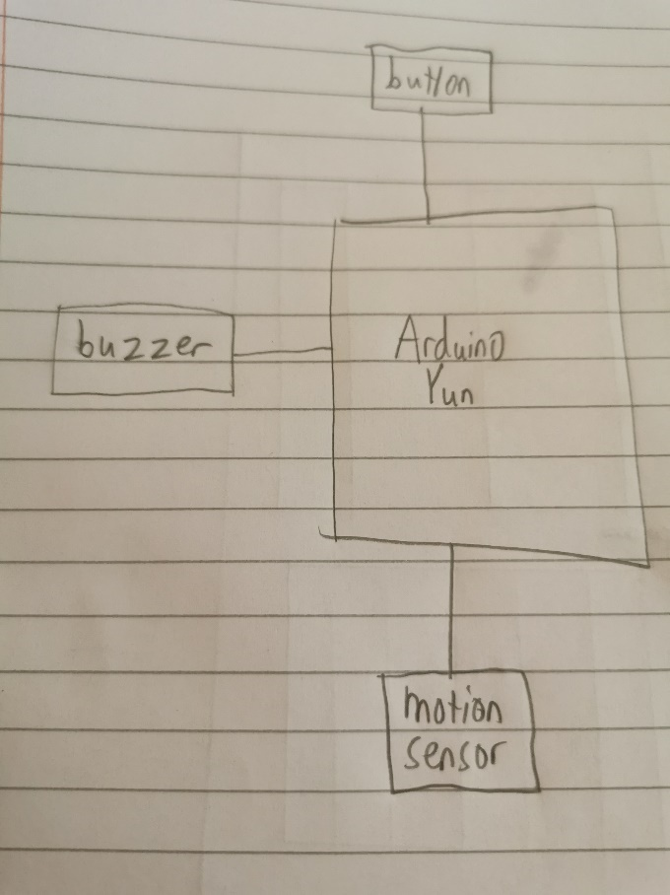The Initial Design

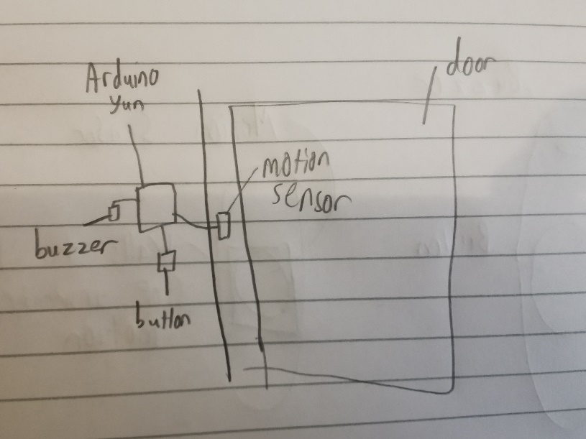

These were our initial design’s, it was very simple design that basically had the motion sensor on the door or near the it so it would only pick up people entering or leaving through the door and not anything else, which was not easy as it was very sensitive to motion and it had to be positioned correctly for it to work the best, Then the Arduino Yun was very close as the cables weren’t that long and the buzzer than was also close by, after the motion sensor was set off the buzzer would go, then we had the button close to the Arduino Yun as it had to be connected to the Arduino and also we had to put it in a place where everyone could see and also where it would easy to identify and easy to press to stop the buzz form the buzzer

Final prototype

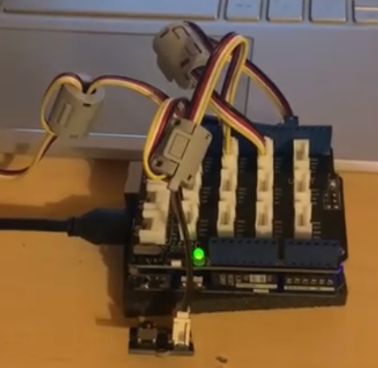

This was the final look and design of this prototype using the Arduino Yun it came out just as we thought as there is not much we could design with using the Arduino Yun, as all the cables can only go so far from the Arduino Yun and from each other,

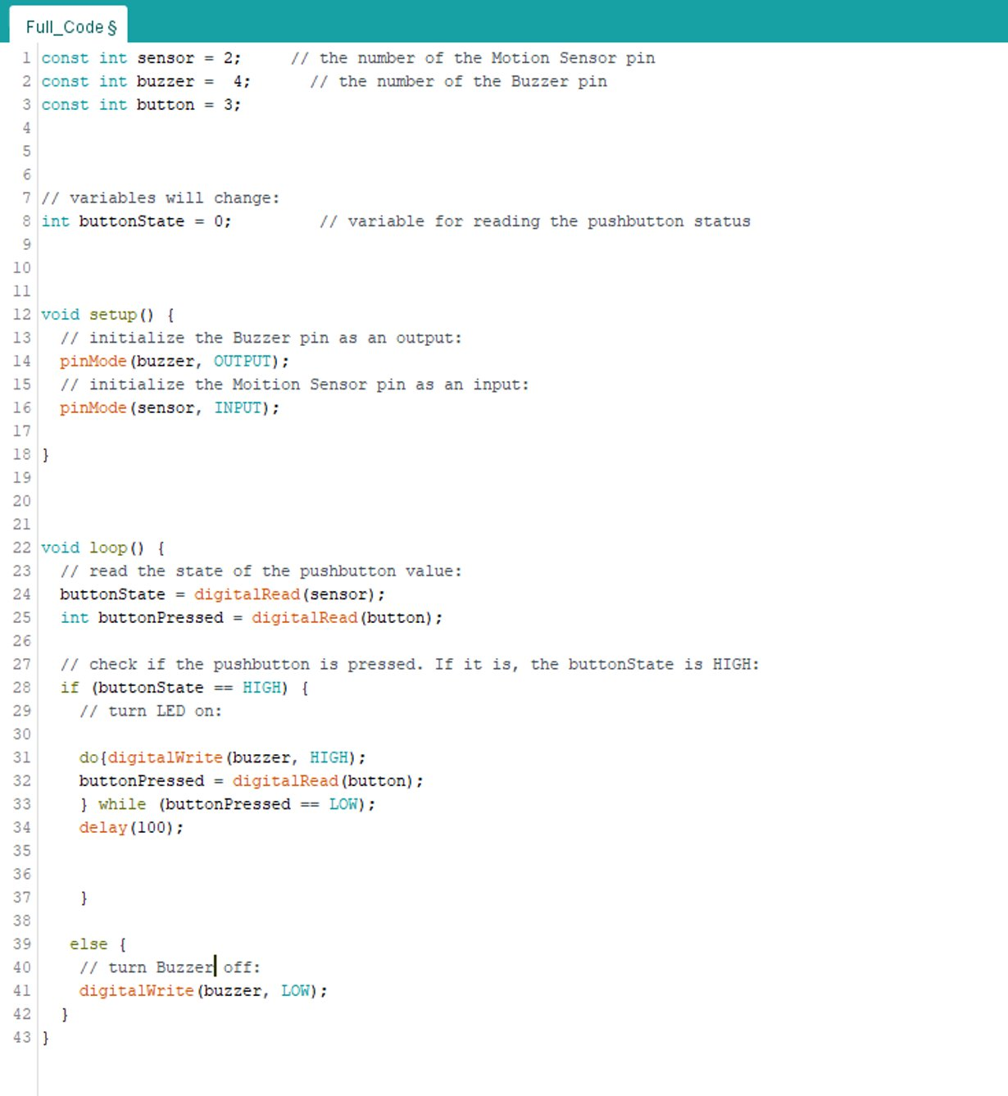The Proposed Code design

 The code was very simple, As it had the Motion sensor as the input to the Arduino Yun and it had the Buzzer as the output for the Arduino Yun, We also put a button in it too which we will explain later, In the Void Loop() When the motion sensor reads HIGH it means that it has just sensed someone, or thing move by it causing it to activate and become HIGH, we added an if statement where if the motion sensor became HIGH it would trigger the buzzer to buzz, The buzzer was in a do loop which meant it kept looping until the statement was broken which was for the button to be pressed, This all basically means that when the motion sensor is triggered it will cause the buzzer to buzz and keep buzzing till the button is pressed, then after the button is pressed the buzzing will stop until the next someone triggers the motion sensor in which case it will basically restart the cycle again

The Proposed Design

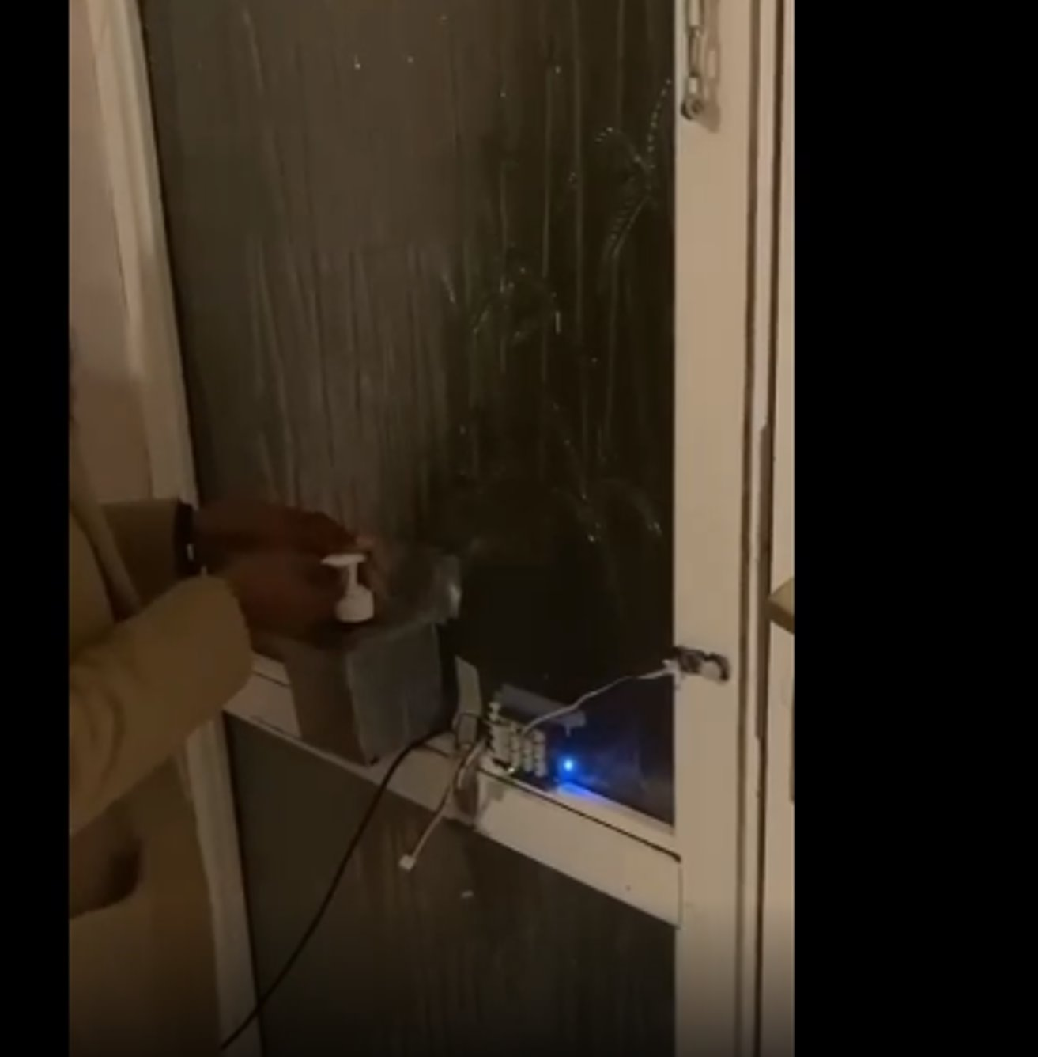

This was the proposed design with the motion sensor beside the door,

The Arduino Yun beside the motion sensor, buzzer and button,

The button in a very accessible position,

And the buzzer being in a place where it can be heard and not be able to get covered in dirt or dust to cause it harm

API

We did not use any APIs for this prototype as it was only designed for people’s home in mind and not for business or other public places that would be able to use its data,

In our next project we are going to hopefully use an API and to be able to calculate how many people who came in to the shop or building and how many people sanitised their hands and also then those who didn’t use our prototype at all and didn’t sanitise their hands, we will also include for those people who sanitise their hands coming into the shop or building

Testing

We tested different types of sensor to see which one would work the best

Light Sensor

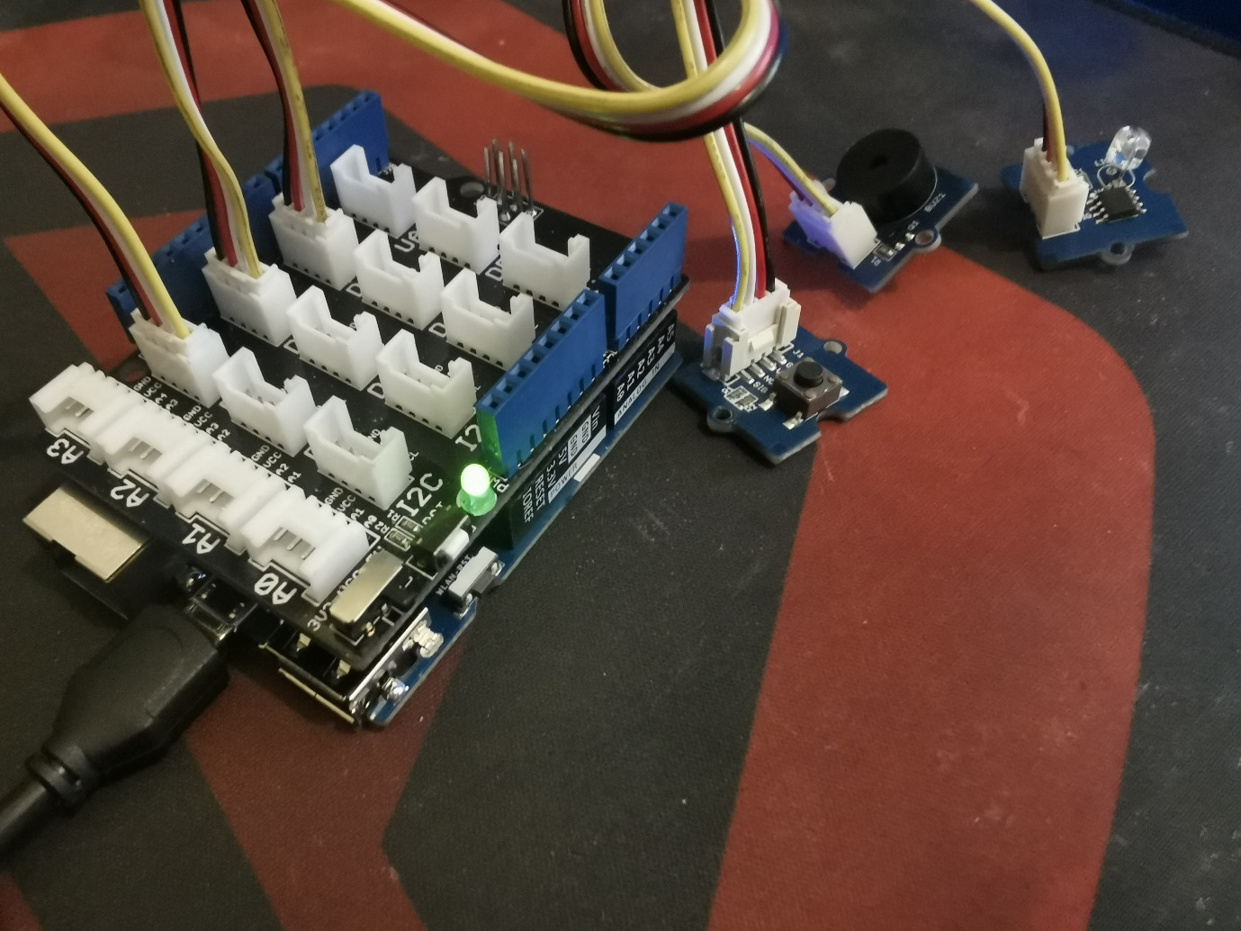

The light sensor was not that great as it would do what we needed the only issue was it needed a light source every time someone would enter the door or leave through which was very hard and not particle to do for our prototype

Sound Sensors

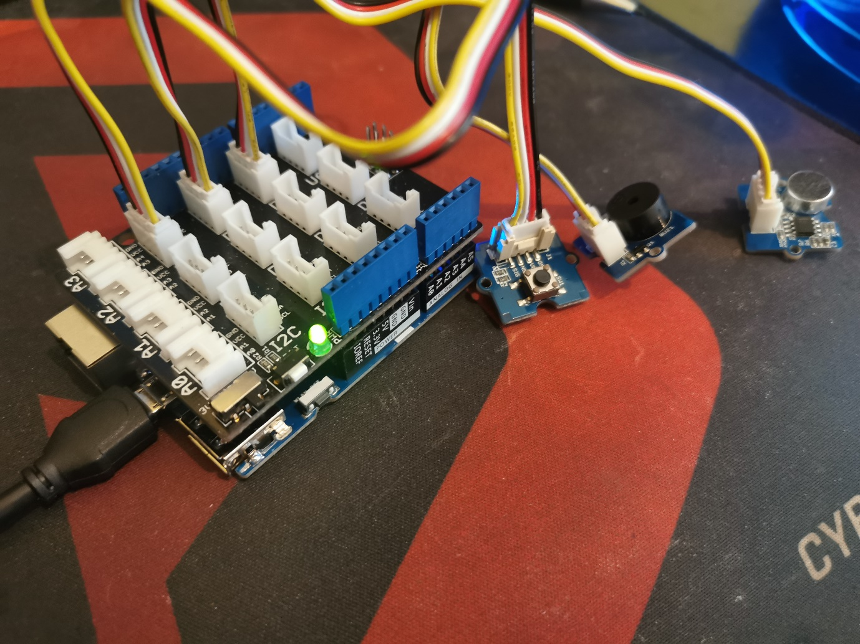

The Sound Sensor was not that great either as it would get triggered by not just the door closing and opening but it would get triggered by other unwanted noises which was not that great for our prototype as it would get set off for the wrong reasons and would become more of a nuisance to the owner and the Arduino Yun as it was not designed to go on for such long periods of time

The Motion Sensor



The motion sensor was the best as it would only pick up motion and not noise which can be very annoying as its easy to create or get unwanted noise, We chose it because it was perfect because there is a lot of motion from the door when it opens and closes from people coming in and out from the door,

The Code

We used the same code for them all, because all we needed from the sensors was a HIGH reading to trigger the buzzer which from the light sensor would be a light shone in it or a light source being shown,

For the sound sensor it would have been the noise of the door or the noise people entering which would have made it HIGH,

Then for the motion sensor it would have been the movement of the door closing and opening and people walking in and out which would have made the motion sensor HIGH

That is why we used the same code for because there was not much difference in all the sensors as all of them would report HIGH If they sensed something of their own type

Security Analysis

Our Arduino Yun was not connected to the internet so there was very little risk involved as it was very secure and used mainly the code which was written to it, as it was primarily designed for homes and people coming home and leaving home for them to sanitise their hands before they came in or left to stop the spread of covid-19,

In out next prototype, We plan to use an API which means it will be connected to the internet which also means that it will increase the security risk as someone could connect to the Arduino and can access to the internet, What we could do to stop this is by encrypting the Arduino Yun with a password which would be randomised with numbers, letters and symbols to make it very hard to access, we would also like to add another password which kick in if they tried to configure the Arduino Yun or try to get any info which would be longer and a lot more secure, This is all we could do to prevent anyone from hacking into it, We also could have someone bodyguard it or have a CCTV camera watching it so that no one would get close enough

Future

For the future of this device if we were to make it more main-stream or take a business standpoint and had the freedom of making the device look how ever we wanted we would make it look like this

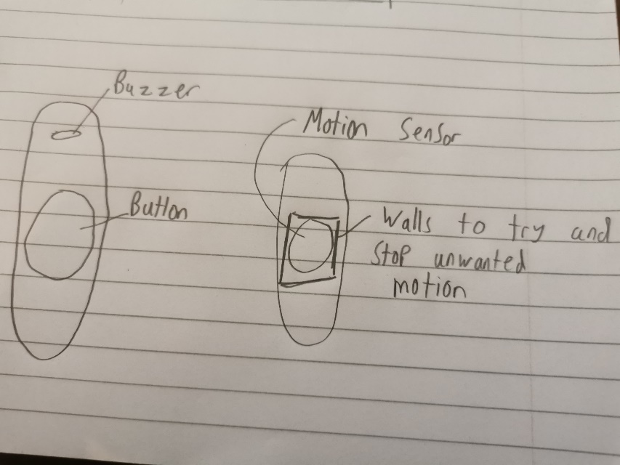

With this type of design we would be able to place the motion sensor outside as it would be able to withstand the outside weather conditions and it would also be more specifically designed to pick up only the motion of people walking through the door or leaving through it we would try to add a type of wall to the sensor to narrow the scope it sense so we could narrow the chance of it getting triggered by any disturbances or other motions we also might be able to change the sensitivity of what the motion sensor can pick up which could also help us narrow the chances of the buzzer going off for now reason because the sensor got triggered over nothing which is not what we had intended with our design, we also could make this a door bell and combine the features in 1,

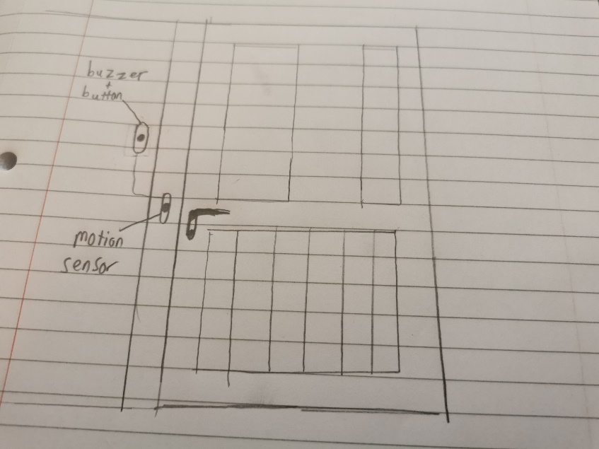

In this sketch we have what we would like the door to look like with our sensor,

Basically, we have the motion sensor picking up the door opening or closing, or someone walking close to it which will then set it off

This would be the type of deign we would try to achieve if we were to become a company and attempt to sell this product